Modeling tsunami inundation for hazard assessment of Barbados

Natalia Sannikova^{1,2} and Christopher Moore¹

¹ NOAA Center for Tsunami Research/Pacific Marine Environmental Laboratory (PMEL), Seattle, WA
² Cooperative Institute for Marine and Atmospheric Research (CIMAR), Honolulu, HI

A B S T R A C T

A scenario-based tsunami hazard assessment for Barbados was conducted. The tsunamigenic earthquakes most hazardous to Barbados were identified by using sources suggested by seismic expert panels and in the literature. Eight sources were identified and used in this study to test their regional impact. The non-linear shallow water wave inundation model HySEA was used to produce maximum wave amplitudes, currents and time series at specific locations to aid in updating evacuation maps for the area.

1. Introduction

This report documents the tsunami inundation modeling for Barbados performed by the tsunami research group at the Pacific Marine Environmental Lab (PMEL) in Seattle, WA. The results of the modeling study produced inundation data for the purpose of developing inundation maps for Barbados under the UNESCO IOC Tsunami Ready Project. Advances in tsunami modeling and hardware make it possible to model the entirety of Barbados at high resolution (10 m). Barbados has long been known to have a significant risk of tsunami inundation due to the surrounding active fault system in the Caribbean (Harbitz, et al., 2012), and the historic record of the region confirm that large events are possible. All identified subduction zones and fault systems in the Caribbean that are identified as tsunamigenic were considered, and sources with significant impact to Barbados were included in the study. The largest credible seismic scenarios that impinge on Barbados were identified and modeled with a fully non-linear shallow water wave model from initial deformation to regional propagation to inundation. Hazards from inundation and currents were assessed for each source, and composite maximum plots were created suitable for creating evacuation maps.

2. Study Area

The study area includes the entirety Barbados Island that is roughly triangular in shape, the island measures 20 miles from northwest to southeast and about 15 miles from east to west at its widest point. It has a population of about 287,000. Its capital and largest city is Bridgetown with 110,000 population (Figure 1, a).

Barbados is the easternmost island in the Lesser Antilles. The Lesser Antilles are a group of islands in the Caribbean Sea. Most of them are part of a long, partially volcanic island arc between the Greater Antilles to the north-west and the continent of South America. The islands of the Lesser Antilles form the eastern boundary of the Caribbean Sea where it meets the Atlantic Ocean (Figure 1, b).

The Coastal Zone Management Unit (CZMU, Barbados) shared with PMEL the Light Detection and Ranging (LiDAR) Digital Elevation Map (DEM) with very high resolution (1 m) on island wide coverage out to depth of about 30 m. Runs of grids at this maximum size typically take several days to weeks to run each source. Extrapolated from 1 m – 10 m resolution grid was used to speed up the process.

The National Tsunami Hazard Mitigation Program (NTHMP)-approved and benchmarked HySEA model was selected to allow full-island modeling at full resolution, which simplified extent choices: all critical infrastructure and inhabited regions are included in the inundation grid, allowing the dynamics of model to show which areas are hazardous without having to estimate where waves might be focused for any given source.

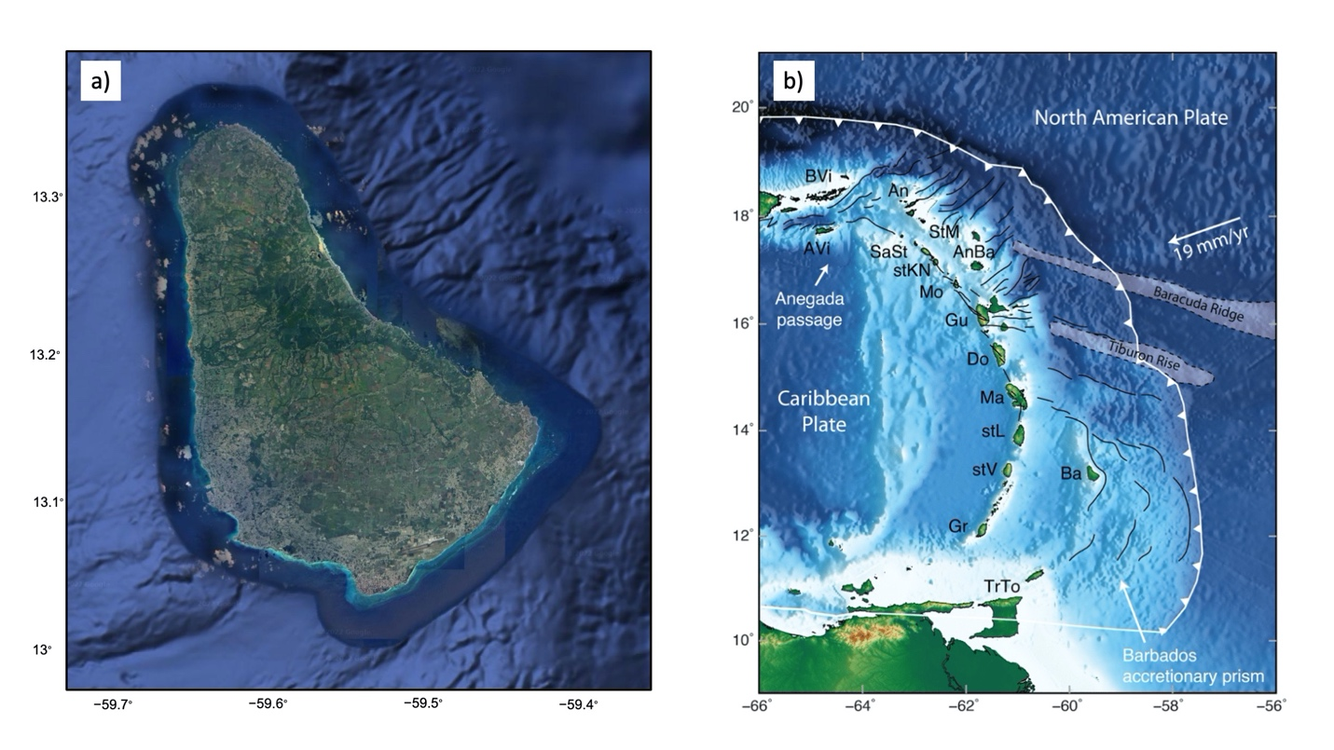
Figure 1: a) Barbados Island (Google Earth), b) seismotectonic setting of Lesser Antilles subduction zone (Rijsingen, et al., 2021).

3. Tsunami Event History

The Caribbean has a rich history of natural hazards, including earthquakes, landslides, and volcanic activity. The NOAA National Centers for Environmental Information (NCEI) Global Historical Tsunami Database (NCEI, 2018) contains data on tsunamis generated from these hazards from 2100 BCE to the present, and shows that of the 51 tsunami events in the region, 37 were earthquake generated, 8 were landslide generated, and 6 were from volcanoes. Seven historical tsunamis caused deaths in the Caribbean Islands totaling over 4000 dead or missing.

3.1. Regional Seismicity

The Caribbean is a complex seismic area, and while this report defines the most important sources used, its goal is not a complete analysis of the seismicity and tectonics of the region. For a complete analysis, see for example Molnar and Sykes (1969).

Barbados, Trinidad and Tobago (all on the Caribbean Plate), and islands off the coast of Venezuela (including the Leeward Antilles) and Colombia were formed as a result of the Caribbean Plate with the South American Plate interaction. The geologically complex Caribbean Plate southern boundary is in part the result of transform faulting, along with thrust faulting and some subduction. The Caribbean Plate is moving eastward about 22 millimeters per year in relation to the South American plate. This process is ongoing and is responsible not only for many of the islands, but also for volcanic and earthquake activity in the region (Figure 2).
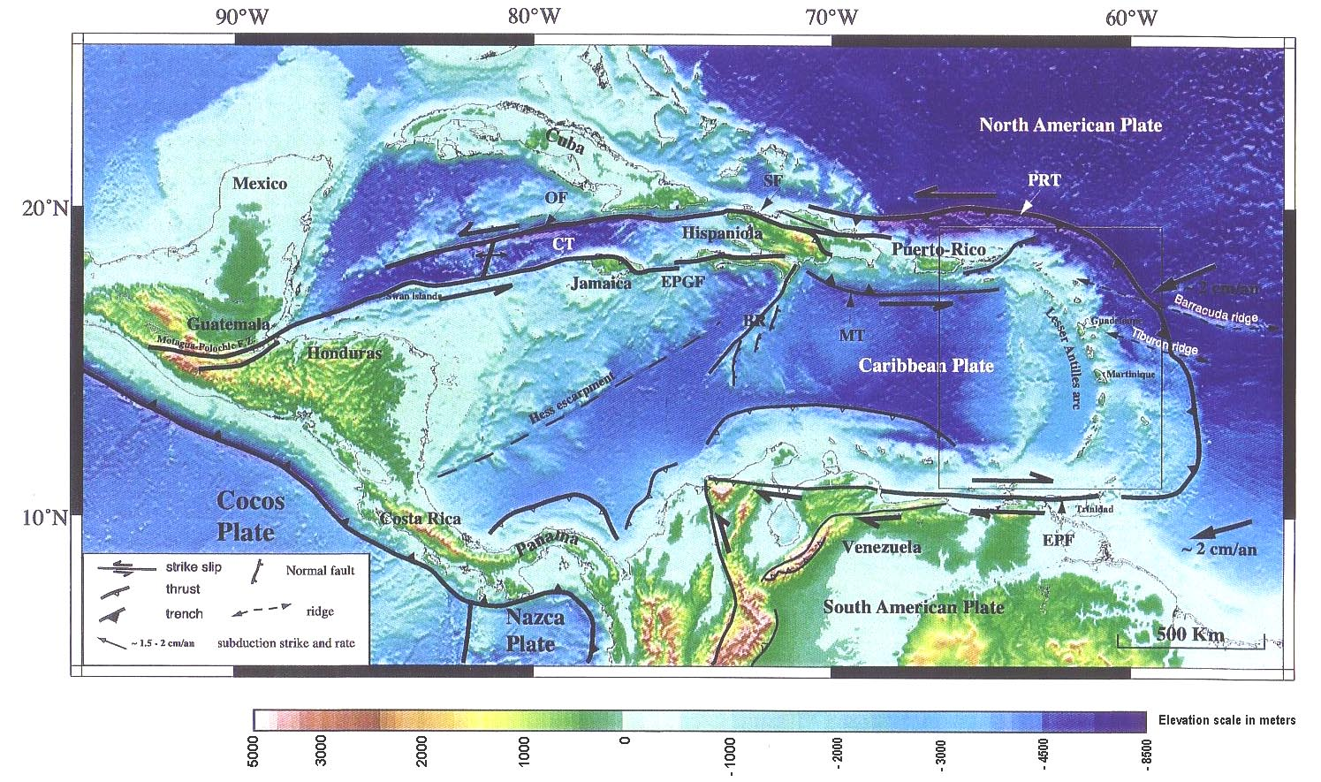

Figure 2: The Caribbean region geodynamic context. Bathymetry from Smith and Sandwell (1997).

3.2. Tsunami Events

The America/Caribbean subduction zone and the tectonic zone (inside the American plate), with its mechanisms of normal and reverse faults, are the zones likely to store the most energy and are thus, the potential sources of tsunami dangerous for Barbados. Tectonic tsunamis are expected to be more important regionally than volcanic and landslide tsunamis.

According the data from the NOAA/NESDIS National Geophysical Data Center and the tsunami catalogue for the whole Caribbean Sea from Lander, et al., 2002 24 tsunami events in the Lesser Antilles can be selected for the whole historical period (Zahibo and Pelinovsky, 2001). The earthquakes produced most of the events (16). Five of them are known to affect the Barbados. The summary of these events is presented in Table 1.

Table 1: Historical tsunami events that affected Barbados

Date | Tsunami Origin | Runup at Barbados [m]
1751, November 20 | a tsunami of unknown origin | 3.6
1755, November 01 | a teletsunami generated by a strong earthquake near Lisbon, Portugal | 1.5 – 1.8
1761, March 31 | a teletsunami generated by a strong earthquake near Lisbon, Portugal | 1.2
1939, July 24 | the eruption of Kick ‘em Jenny submarine volcano | 1 – 2
1969, December 25 | a Mw 7.6 earthquake with epicenter coordinate: 15.8 N 59.7 W | 0.46

Unfortunately, the quantitative information of each coastal location is poor. It confirms that tsunamis waves with height of 1 m can be expected once in 100 years but accuracy of these estimates is very low (Zahibo and Pelinovsky, 2006).

4. Tsunami Source Scenarios

Due to the complexity of the tectonics and the fact that probabilistic tsunami hazard assessment techniques are still being developed (Løvholt, et al. 2011) we use a scenario-based assessment technique based on credible worst-case tsunami events. Source scenarios used in this assessment were identified in the literature, or by using guidance provided by the Intergovernmental Coordination Group of the Early Warning System for Tsunamis and Other Coastal Threats in the Caribbean Sea and Adjacent Regions (ICG/CARIBE-EWS) Hazard Assessment Working Group (WG2). This group has been assigned the task of identifying potential tsunami sources. The ultimate goal of WG2 is to develop tsunami evacuation maps using those scenarios among others, as well as to provide future scenarios for CaribeWave exercises. During 2019, IOC/UNESCO sponsored Experts Meeting on Tectonic Tsunami Sources focusing on Lesser Antilles. The group identified a total of six thrust segments from north to south: EPTR, NLA1, NLA2, BRTR, BARB and eslat. Marine geological and geophysical studies have identified possible normal-fault sources along the Barracuda (BARRA) and Tiburon (TIBU) ridges (Figure 3).

In segments NLA1, NLA2, BRTR, BARB two sources are identified: Full (suffix ‘f’ is added to the name of the source in Table 2) where both segments are considered, and Shallow (suffix ‘s’) representing a source only rupturing the shallow portion of the thrust interface (yellow rectangles). The sources identified by the WG2 were considered as credible worst-case scenarios for this study. Several of the recommended sources were ruled out either because of directionality – NLA1, NLA2 (tsunami energy is directed at 90° to the fault long axis) or simply by considering distance and size – EPTR (distant, small sources would not reach the Barbados).

The far-field 1755 Lisbon event was added to consideration as the largest earthquake generated tsunami outside the Caribbean region with known origin that had impact on Barbados. The source parameters were taken from Barkan, et al., (2009), but scaled in magnitude to match the evidence in Anegada put forth in Atwater, et al. (2012) (Moore and Arcas, 2019). All the parameters listed assume the epicenter location (longitude/latitude), and depth are for the center of the fault plane.

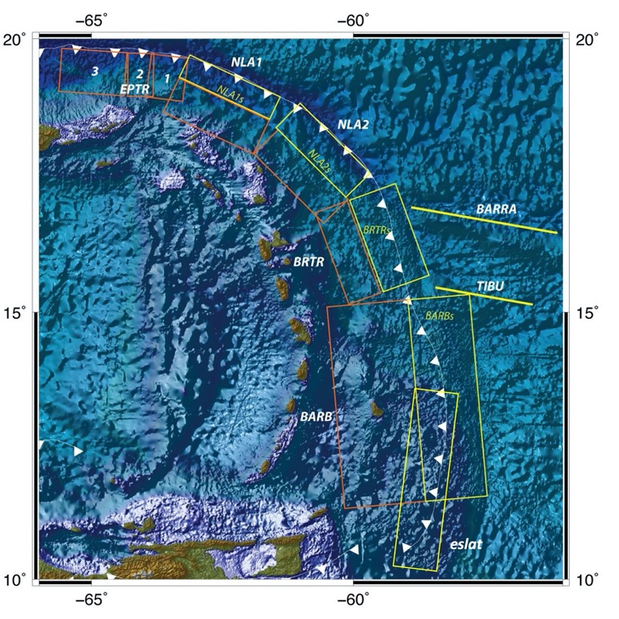
Figure 3: Seismic earthquake sources considered in this hazard assessment. For the Lisbon 1755 source, see source figures later in this section.

The source parameters are listed in Table 2. BARBf, BARBs and eslat are nearfield sources, causing much more inundation than the others (Figure 4). Despite BARBf is the biggest sources BARBs is the most catastrophic for Barbados.

Table 2: Seismic parameters of scenario sources used in this study.

Source # | Name | Segm. # | Lon | Lat | Depth (km) | Length (km) | Width (km) | Strike (°) | Dip (°) | Rake (°) | Slip (m) | Magnitude (Mw)
1 | BRTRf | 1 | -60.10 | 16.10 | 40 | 200 | 80 | 160 | 30 | 90 | 10 | 8.63
1 | BRTRf | 2 | -59.31 | 16.38 | 13 | 200 | 100 | 160 | 8 | 90 | 10 | 8.63
2 | BRTRs | 1 | -59.31 | 16.38 | 13 | 200 | 100 | 160 | 8 | 90 | 10 | 8.46
3 | BARBf | 1 | -59.56 | 13.28 | 38 | 420 | 170 | 175 | 10 | 90 | 10 | 9.05
3 | BARBf | 2 | -58.20 | 13.50 | 12 | 420 | 120 | 175 | 10 | 90 | 15 | 9.05
4 | BARBs | 1 | -58.20 | 13.50 | 12 | 420 | 120 | 175 | 10 | 90 | 15 | 8.86
5 | eslat | 1 | -58.50 | 12.20 | 15 | 400 | 100 | 183 | 15 | 90 | 8 | 8.62
6 | BARRA | 1 | -57.50 | 16.70 | 7 | 300 | 15 | 100 | 80 | 90 | 3 | 7.67
7 | TIBU | 1 | -57.50 | 15.30 | 7 | 200 | 15 | 100 | 80 | 90 | 2 | 7.56
8 | 1755 | 1 | -11.08 | 35.97 | 31 | 600 | 80 | 345 | 40 | 90 | 33 | 9.2

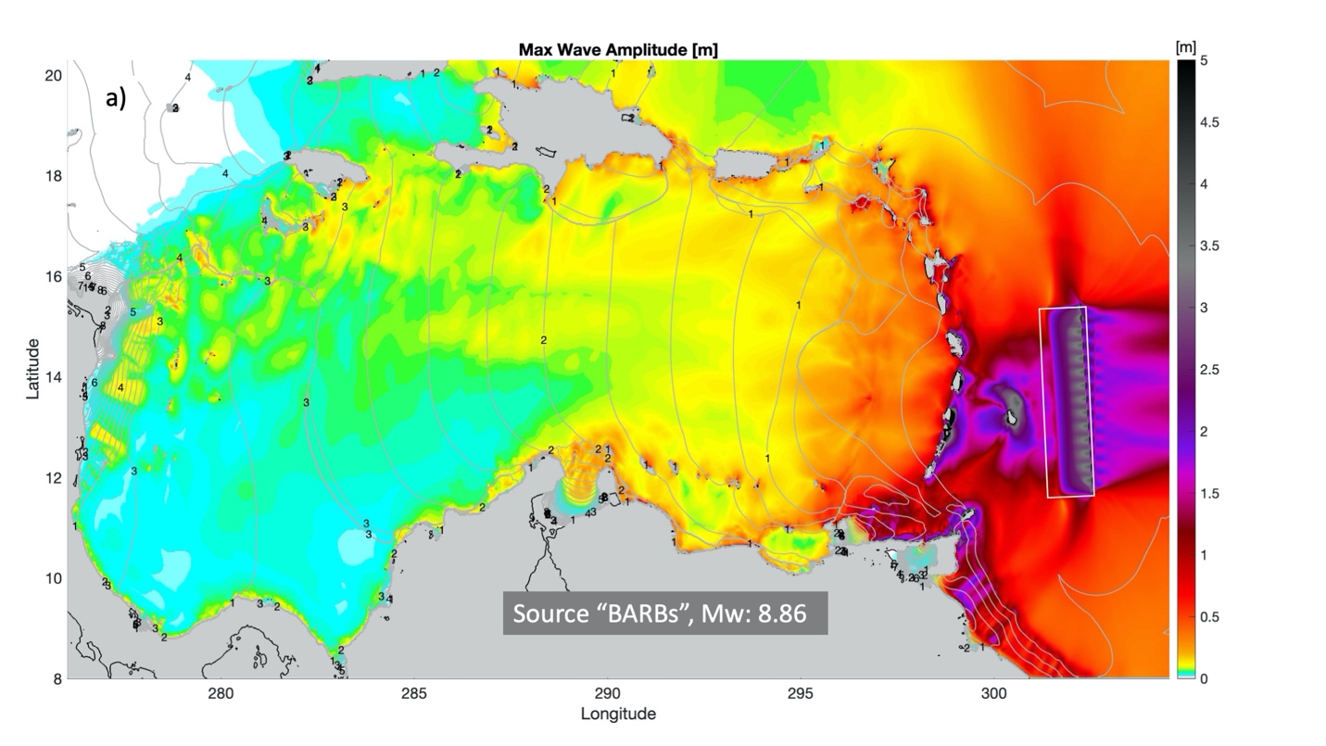
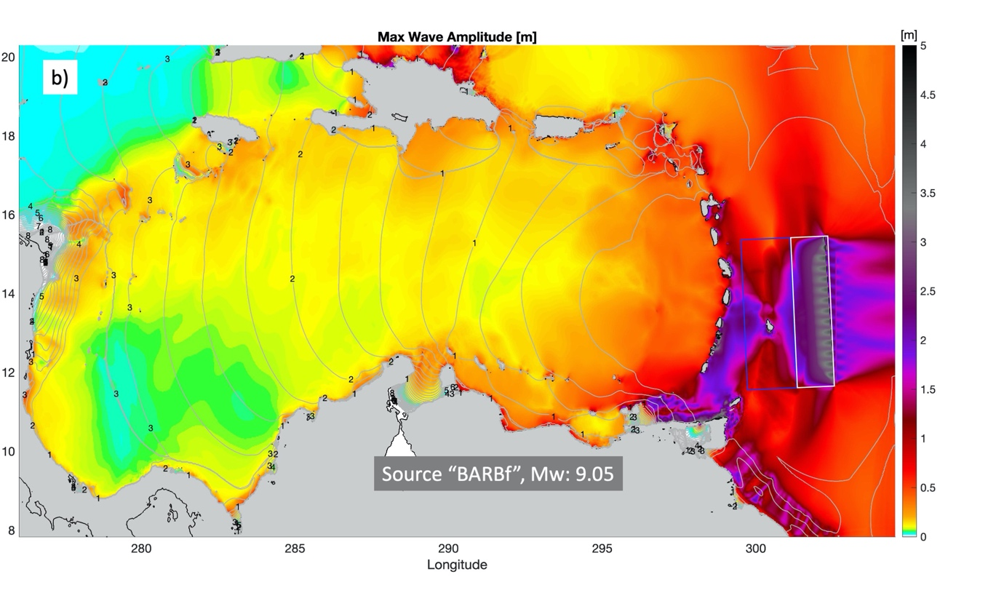
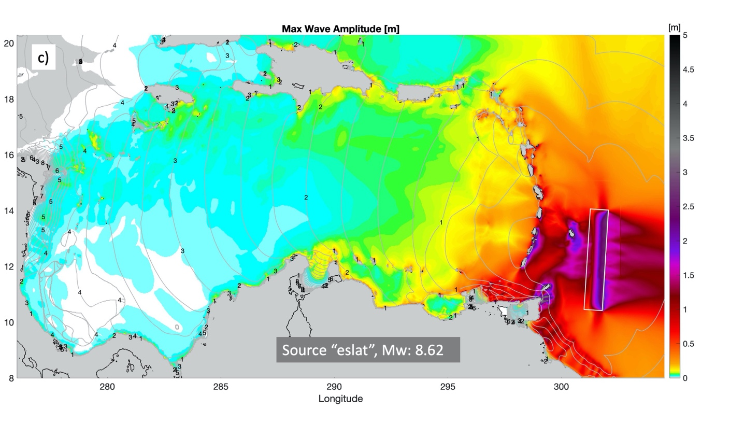
Figure 4: Source location, arrival times, and maximum wave amplitudes for the largest near-field sources:
a) BARBs, b) BARBf, c) eslat.

Figure 5 shows the far-field 1755 Lisbon event, the biggest one with known origin that generated tsunami affecting Barbados.

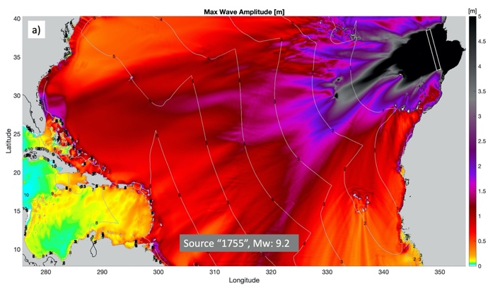 | 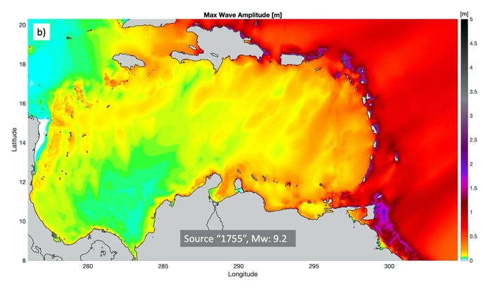
Figure 5: Source location, arrival times, and maximum wave amplitudes for the far-field 1755 Lisbon event:
a) Atlantic Ocean region with source location highlighted, b) Caribbean Sea region.

Figure 6 shows other, smaller sources including BRTRf, BRTRs, BARRA and TIBU.

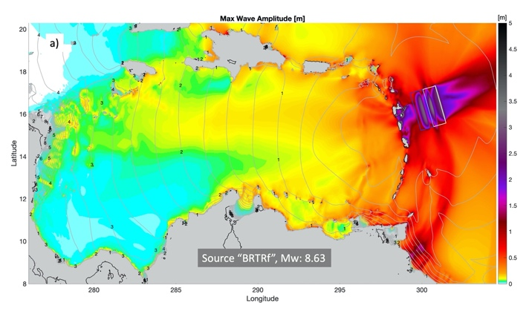 | 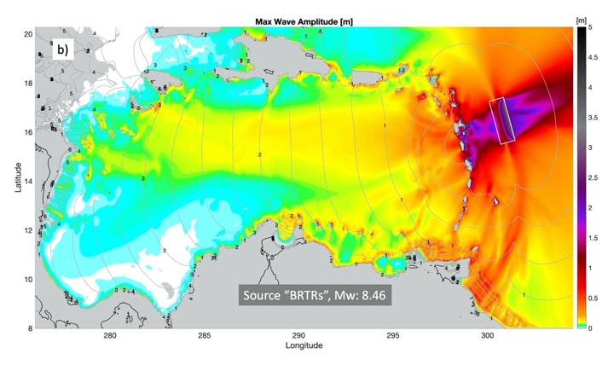
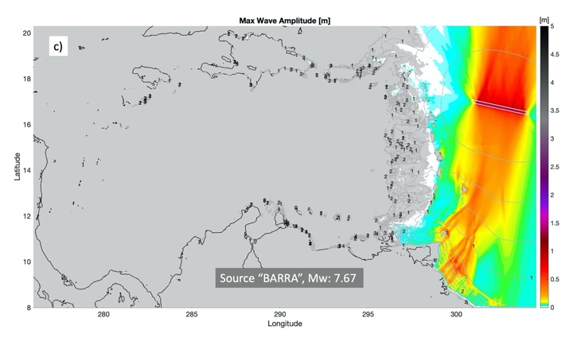 | 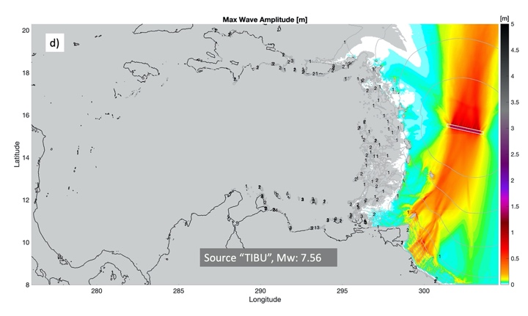

Figure 6: Source location, arrival times, and maximum wave amplitudes for the near-field sources: a) BRTRf, b) BRTRs, c) BARRA, d) TIBU.

5. Tsunami Model and Grid Development

High resolution (1 m) LiDAR DEM data is available for Barbados on island wide coverage out to depth of about 30 m, allowing for very accurate inundation modeling with taking into account all coastlines’ specificities and critical infrastructure. On the other side the data contain false topographic features like boats and bridges. Runs of grids at this maximum size typically take several days to weeks to run each source. Extrapolated from 1 m to 10 m resolution grid was used to smooth the data and speed up the process without significant loss of accuracy.

The resulting bathymetry (Figure 7, a) had bathymetry gaps (Figure 7, b, c) that were eliminated with inner interpolation where possible or outer bathymetry fulfillment from interpolated nine arcsec DEM. The temporary (false) bathymetry features like boats were also eliminated and/or smoothed (Figure 8).

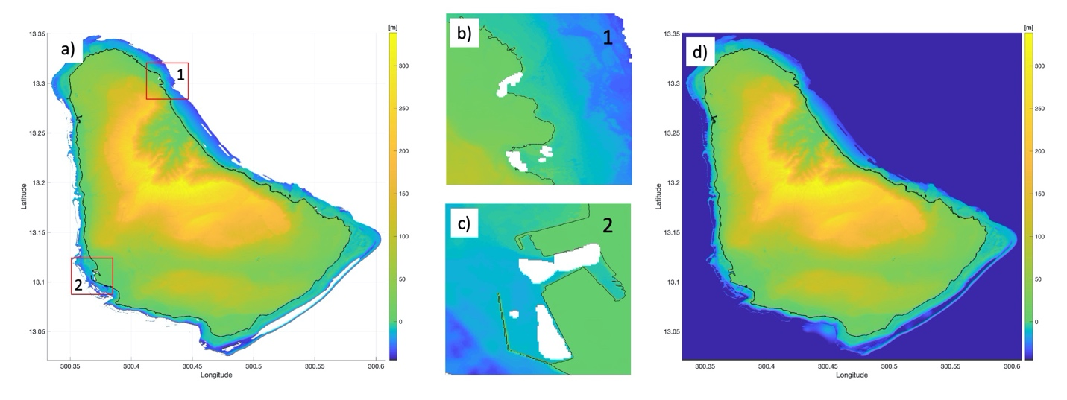
Figure 7: LiDAR DEM data gaps elimination: a) 10 m bathymetry map with gaps, b) Cove Bay gap, c) Bridgetown Port gap, d) resulting bathymetry map.

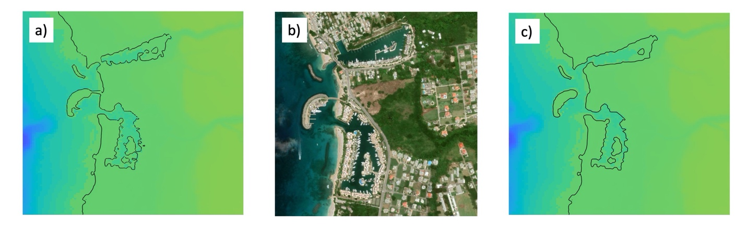
Figure 8: LiDAR DEM false bathymetry features elimination: a) Port Ferdinand – Port St Charles area with boats reflected, b) Port Ferdinand – Port St Charles area from Google Earth, c) Port Ferdinand – Port St Charles area with false bathymetry features eliminated and/or smoothed.

Due to a recent collaboration with the University of Malaga, Spain, the NOAA Center for Tsunami Research (NCTR) has access to a relatively new model, HySEA – an NTHMP-benchmarked inundation model. The benchmarking involves extensive testing against a number of theoretical, laboratory, and field data summarized in Synolakis et al., 2008 and NTHMP, 2017. This tsunami model code has been designed to solve the non-linear shallow water equations and utilizes GPU graphics cards for parallelization, making it suitable for very large, very high-resolution grids. The HySEA model was earlier validated against the MOST model used in the operational forecasting of tsunami inundation at NOAA’s Tsunami Warning Centers on tsunami modeling of the U.S. Virgin Islands: St. Thomas, St. John, and St. Croix (Moore and Arcas, 2019). The model results showed very similar inundation and the overall maximum of the wave amplitudes.

Full 10 m resolution DEMs were used for the entire Barbados without re-gridding. This ability to use full-resolution DEMs provides the highest level of accuracy for each given earthquake as the re-gridding process can introduce errors in model output. The nested grids are implemented in the HySea model keeping the accuracy-speed balance. Three levels of larger grids contain these highest-resolution grid, in increasing size and resolution. The HySEA model requires resolution “jumps” between these nested grids only by factors of 2, 4, 8 or 16.

HySEA is a finite-volume numerical model and has grid-alignment nesting requirements that ensure that volume centroids for each cell fall exactly on the cell location for inner grids in the nesting (Figure 9). This requirement, along with the desire not to re-interpolate the source DEM means that the innermost grids be developed first by determining extent and ensuring that each successive outer grid have resolutions that are integer-multiples of inner grids.
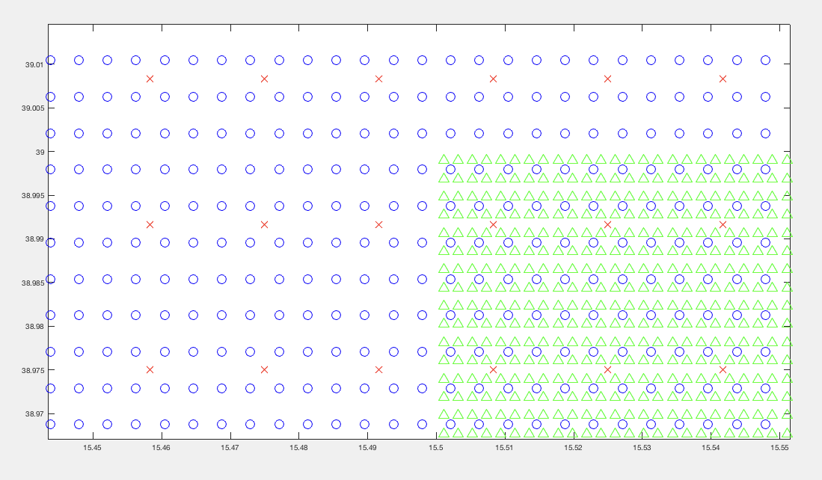

Figure 9: Grid nesting for HySEA showing innermost grid points (green) of twice the resolution of intermediate grid points (blue). Intermediate points have four times the resolution of outermost grid points (red) from Moore and Arcas (2019).

The grid resolutions are shown in Figure 10, innermost (red frame) 10 m, intermediate (yellow) 2.625 arc-second,
regional (green) 21 arc-second, and outermost (magenta) 84 arc-second. A separate outermost grid was made for the entire north Atlantic extents to include the 1755 Lisbon event in the assessment. Publicly available elevation (including ocean and land) 15 arcsec data set GEBCO was used as the source DEM for the Atlantic grid. The ratios between resolutions are, therefore, 8, 8, and 4, respectively.

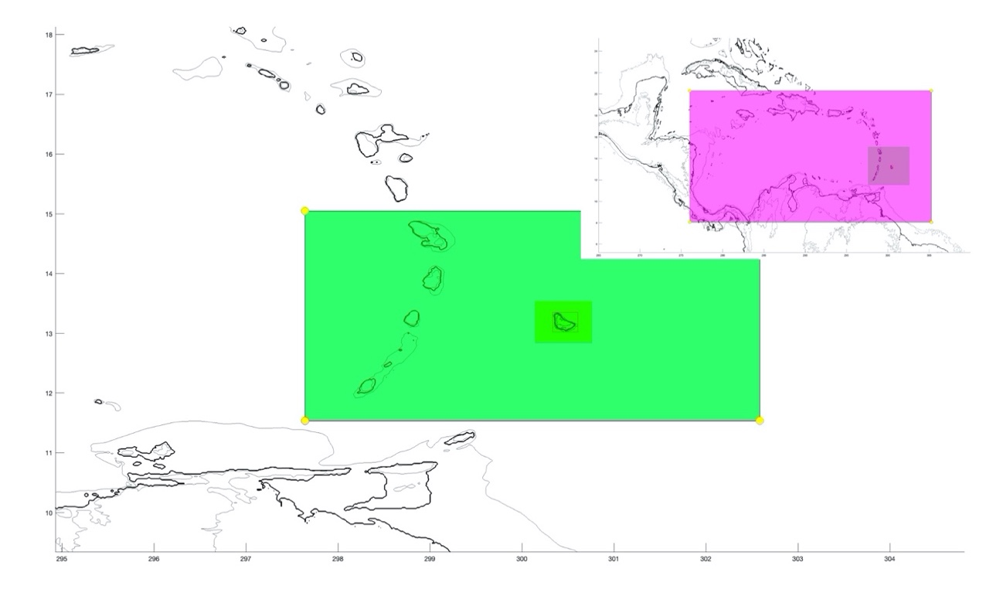
Figure 10: Extents of the grids: outermost (magenta) encompasses almost the entire Caribbean, the intermediate (green) includes part of Lesser Antilles from Martinique to Grenada, the next level (yellow) includes Barbados shelf up to 100 m, and the innermost grid (red frame) includes only the island of Barbados.

6. Modeling Results

The model was run for each of the eight sources described in Section 4. Maximum wave amplitude and maximum current speed for the whole simulation were saved at every grid point every 60 seconds in order to produce inundation maps. Wave amplitude variations and current speeds were saved at the most populated locations every 30 seconds. Wave amplitude and current velocity were saved every 30 seconds for the first two hours of the simulation at every grid point for the most hazardous for Barbados source BARBs to track the tsunami wave dynamics.

6.1. Wave Arrival

Figure 11 shows the tsunami arrival to Barbados from the most hazardous source for that island – BARBs. The wave arrives from the east starting with the recession of water (drawdown) and reaches its maximum amplitude at Crane Beach in about 15 minutes after the earthquake, at Walkers Beach in about 17 minutes, at Crab Hill in about 20 minutes, at Oistin Bay in about 24 min and at Brighton Beach in about 28 minutes. The velocity vectors show the wave refracts around the island exceeding the current velocities of 10 m/s at the south of the island and 4 m/s at the north of the island. The maximum wave amplitudes around the island mostly vary within the range of 5 – 10 m exceeding these values at some points of the back side of the island (in respect to the source location) at Oistin Bay and Brighton Beach. That is explained by the wave interference caused by the collision of the waves propagating around the island from the place where the tsunami hits first (Liu et al., 1995, Briggs et al. 1995, Kanoglu, 1998), by the bathymetry specificities and coastline geometry. The wave oscillations around the island attenuate significantly after two hours from the earthquake.

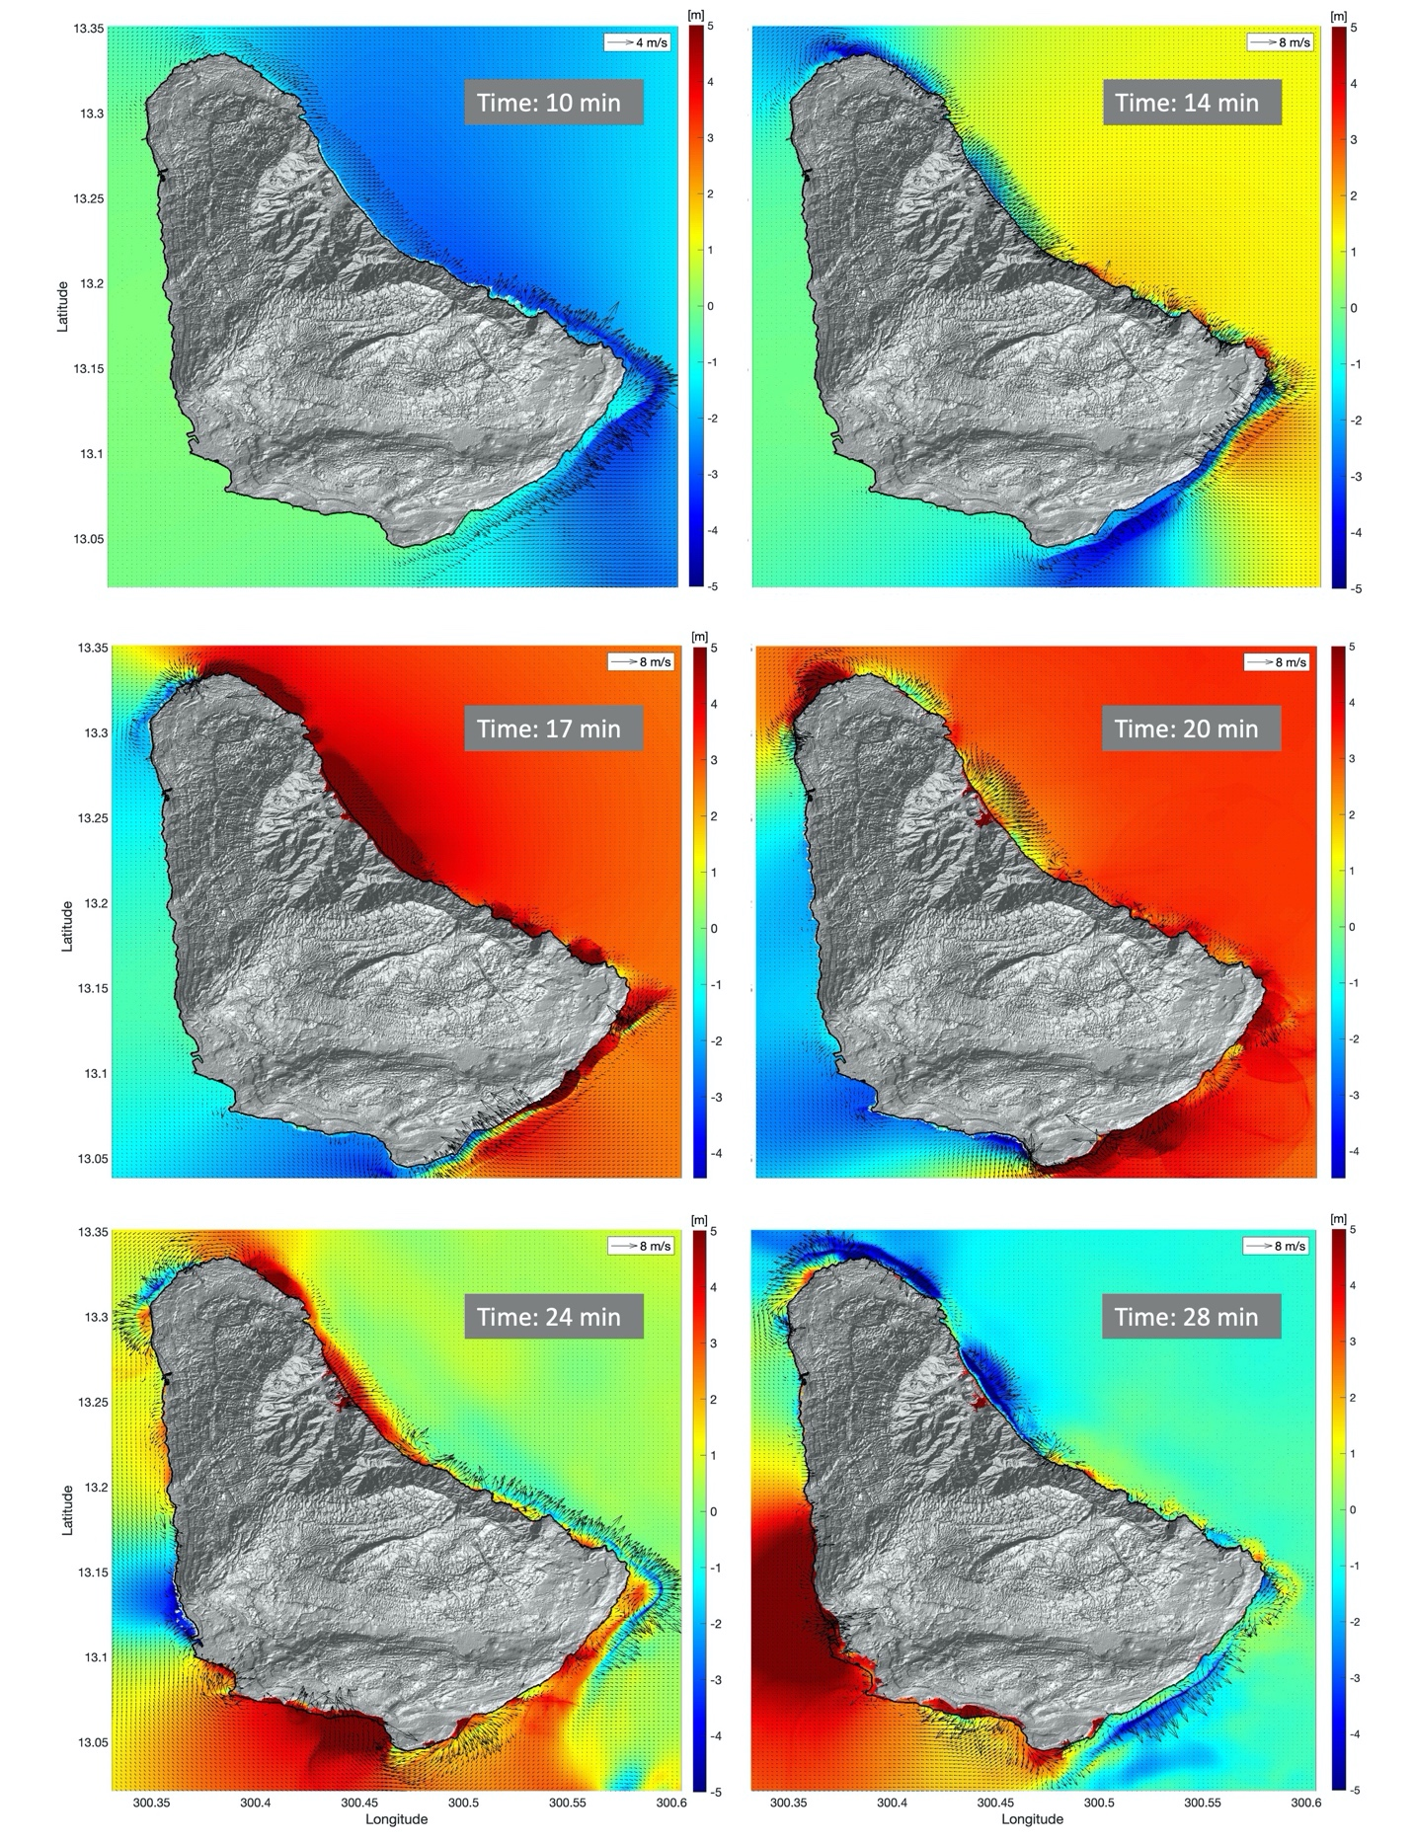
Figure 11: Wave amplitudes and currents (black vectors) at different times (showed on the figure) from the most dangerous for Barbados BARBs source.

6.2. Maximum Wave Amplitudes

Wave amplitude is measured from the vertical datum, taken to be mean high water for this study. Tracking the maximum wave amplitude over all the time steps of a model run gives the largest wave for a given source at all locations on the grid. Wave amplitudes larger than the ground elevation cause inundation, so a plot of maximum wave amplitude gives the “inundation line” or horizontal distance a wave penetrates inland from the shoreline. Figure 12 shows the maximum wave amplitude for three closest and the most hazardous for Barbados sources: BARBs (Figure 12, a), BARBf (Figure 12, b) and eslat (Figure 12, c). The inundation for these events is extensive with the largest values for maximum wave amplitude of 17.5 m, 10.9 m and 8.6 m respectively. The location of these overall maximums is on the south-west part of Barbados in Oistin Bay, a popular tourist destination. The largest area of inundation occurs also in Oistin Bay and at Brandons Beach, Bridgetown close to the Bridgetown Cruise Terminal.

For the BARBf and eslat sources the inundations are less with the similar points of concern. With maximum at Walkers Beach (north-east of Barbados) for BARBf source and next to Harrison’s Point Light house (north of Barbados) for eslat.

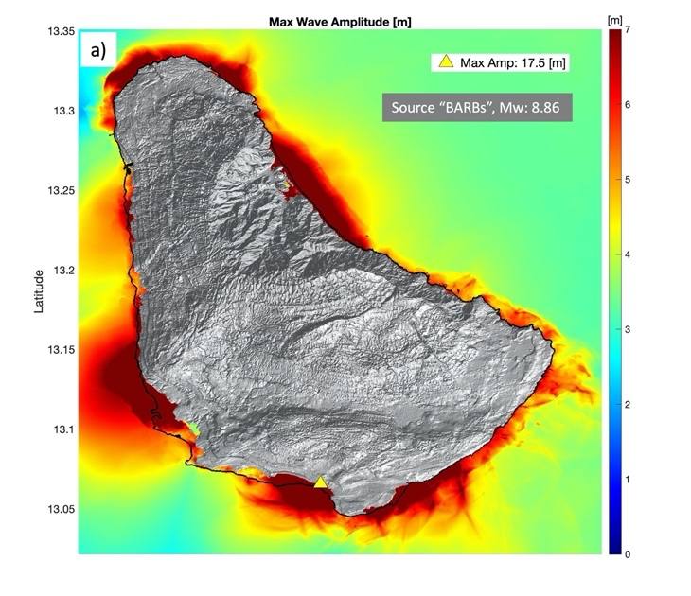
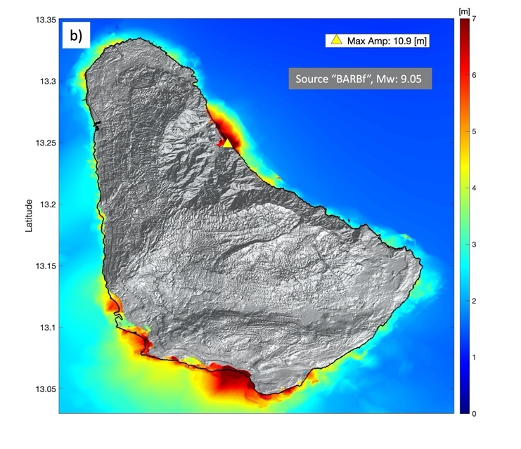
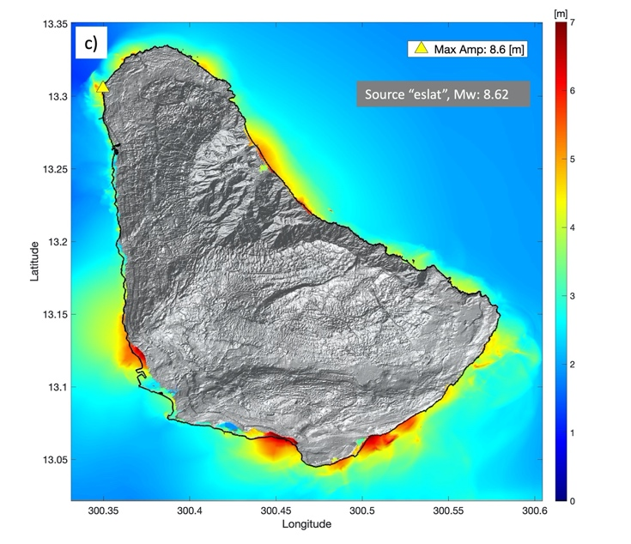

Figure 12: Maximum wave amplitude for the a) BARBs, b) BARBf and c) eslat sources. Yellow triangle marks the position of the overall grid maximum.

The maximum wave amplitude plots show the wave pattern, focusing, and runup height (the maximum ground elevation wetted by the tsunami on a sloping shoreline). But often times the flow depth is a more intuitive quantity. Flow depth is the wave amplitude minus ground elevation, or the depth of water a person in the flood zone sees. With this in mind, we give both maximum wave amplitude AND maximum flow depth for each of the most hazardous sources for each island (Figure 13).

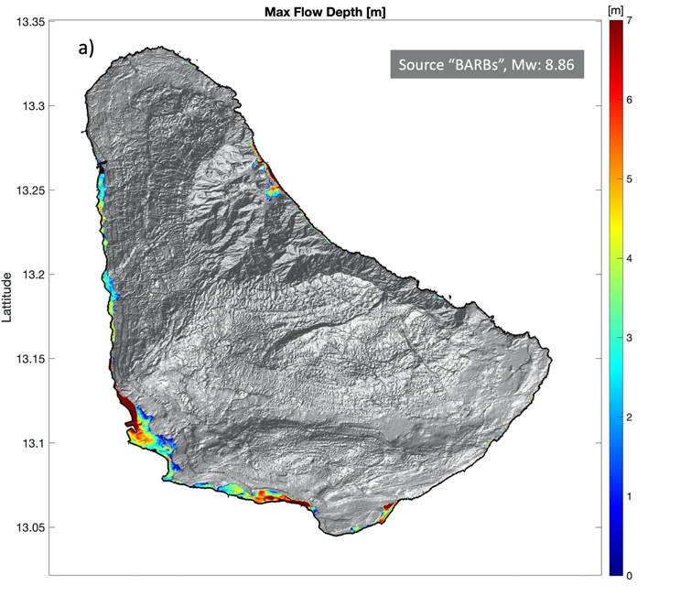
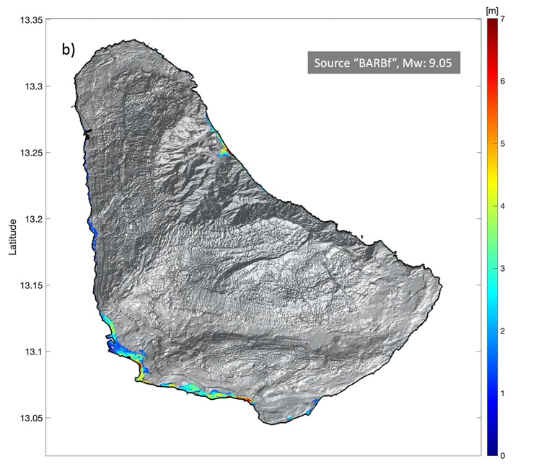
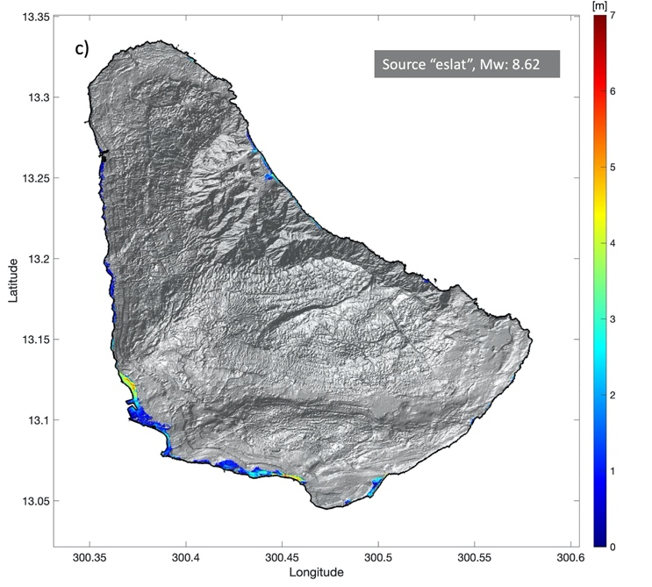
Figure 13: Maximum flow depth for the a) BARBs, b) BARBf and c) eslat sources.

6.3. Time Series at Specific Locations

Saving all variables at every time step for the whole simulation is not possible, but the model allows saving chosen locations at every time step. A list of points for Barbados was generated based on population amount. The wave amplitudes and current speeds were saved at these points (Figure 14).

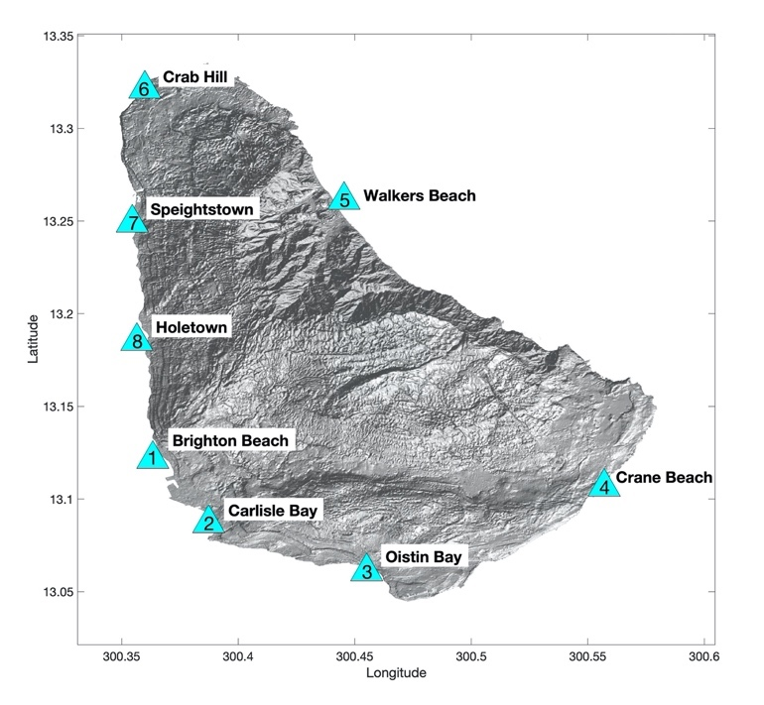
Figure 14: Locations of the synthetic tide gauges.

Barbados maximum wave amplitudes forced by the most hazardous for Barbados BARBs source vary between 5 to 10 meters in the considered locations (Figure 15). The maximum amplitude exceeds 8 meters at Brighton Beach, Oistin Bay, Walkers Beach and Crab Hill. The wave arrival starts with the water recession at the closest to the source locations (Crane Beach, Walker Beach) as soon as the earthquake strikes and at the furthest locations (Brighton Beach) in 12 minutes (Table 3). The following after the water recession water elevation (runup) starts in 14 minutes after the earthquake at the closest locations (Crane Beach, Walker Beach) and in 25 minutes at the furthest locations (Brighton Beach, Holetown). Maximum current speeds and 3-knot current attenuation times (time between wave arrival and when currents drop below 3 knots) are sensitive to harbor geometry as well as distance to source. While Brighton Beach shows the largest current speed, this is just a spike that occurs as the first wave arrives. Oistin Bay and Crab Hill show the largest consistent currents overall, and the 3-knots attenuation time of 1.33 hour is the longest of the time series records (at Crab Hill). The average 3-knots attenuation time is 1 hour. Holetown is the only of the time series plot that do not reach 3-knots current attenuation. The 3-knot attenuation time for Holetown is listed as “NaN” (Table 3).

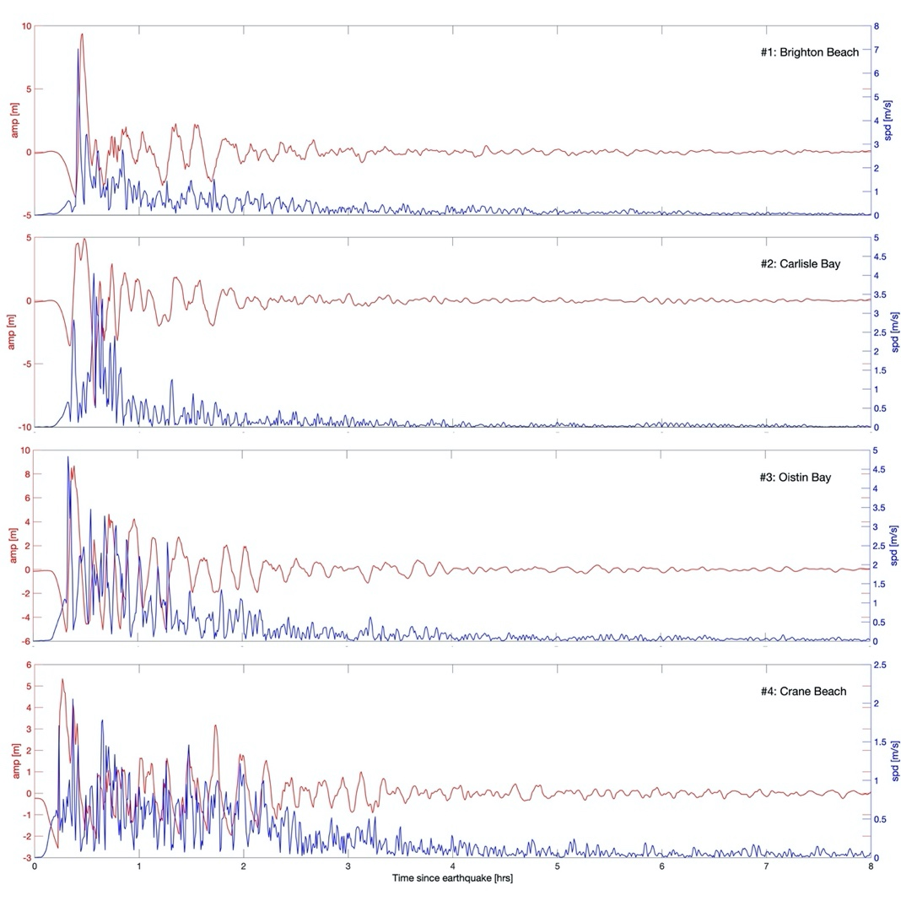
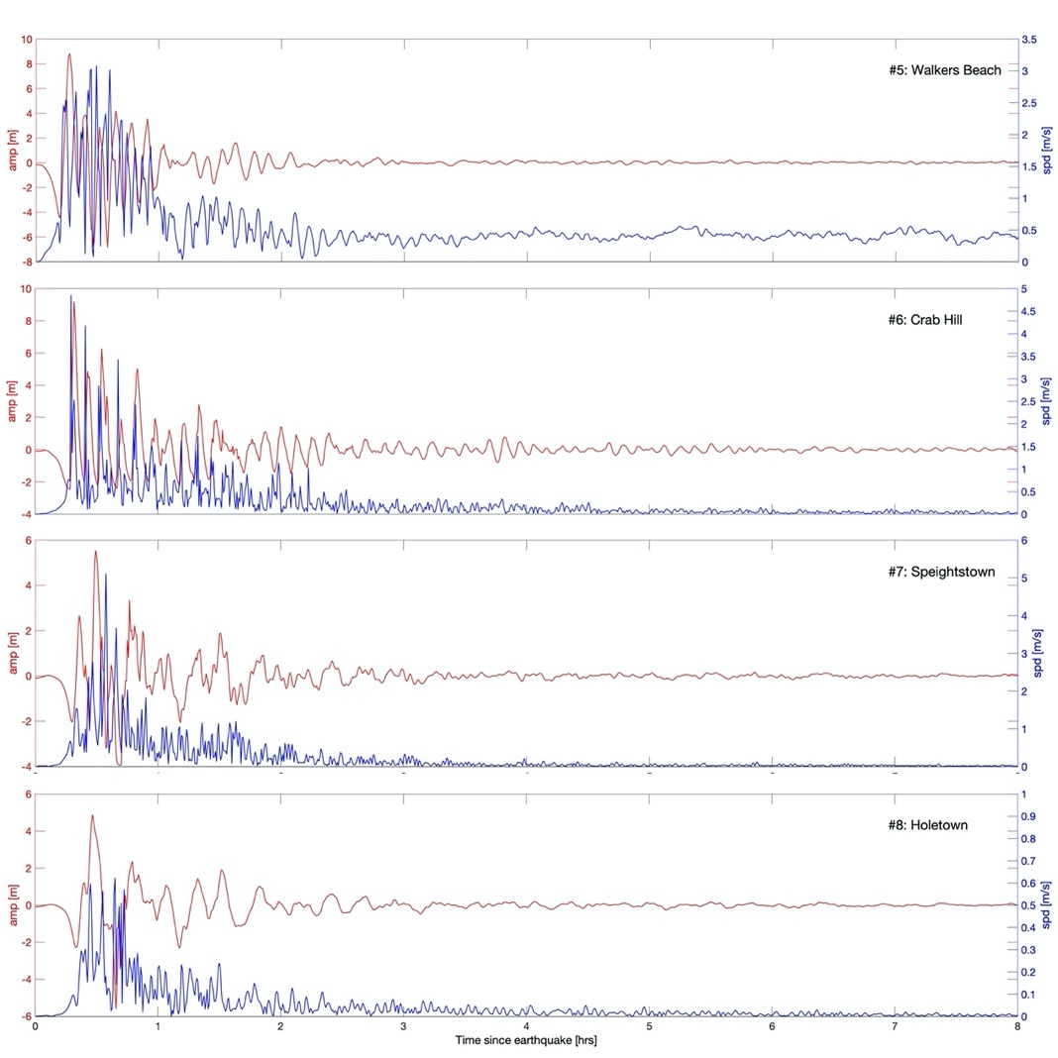

Figure 15: Time series of wave amplitude (red) and current speed (blue) forced with the BARBs source at the most populated locations of Barbados.

Table 3: Statistics for Barbados time series points due to the BARBs source.

Gauge # | Location | Longitude | Latitude | Depth [m] | Min. Amp. [m] | Max. Amp. [m] | Drawdown Arr. Time [min] | Runup Arr. Time [min] | Max. Speed [m/s] | 3-knot  Atten. [hrs]
1 | Brighton Beach | 300.3633 | 13.1215 | -4.24 | -3.62 | 9.38 | 12 | 25 | 7.02 | 0.8589
2 | Carlisle Bay | 300.3874 | 13.0868 | -15.91 | -8.32 | 4.92 | 10 | 22 | 4.05 | 0.8254
3 | Oistin Bay | 300.4551 | 13.0608 | -5.8 | -5.24 | 8.68 | 10 | 20 | 4.83 | 1.2920
4 | Crane Beach | 300.5570 | 13.1065 | -2.9 | -2.56 | 5.34 | 0 | 14 | 2.06 | 0.6588
5 | Walkers Beach | 300.4454 | 13.2613 | -10.98 | -6.83 | 8.83 | 2 | 14 | 3.08 | 0.9338
6 | Crab Hill | 300.3599 | 13.3214 | -2.43 | -2.43 | 9.17 | 7 | 18 | 4.85 | 1.3255
7 | Speightstown | 300.3545 | 13.2490 | -3.95 | -3.95 | 5.53 | 10 | 20 | 5.10 | 0.9002
8 | Holetown | 300.3596 | 13.1849 | -9.18 | -5.61 | 4.88 | 10 | 25 | 0.62 | NaN

6.4. Southwestern Barbados Tsunami Runup

Due to the Southwestern Barbados (from Saint Matthias, Bridgetown to Saint Lawrence, Oistins along the coastline) high population density, the infrastructure importance and tourist destination popularity this area was considered separately (Figure 16). The maximum tsunami amplitudes from the most hazardous for Barbados source BARBs are high in this area varying from 5 to 10 m reaching its maximum value at around Rockley Beach with inundation reaching Rockley Resort.

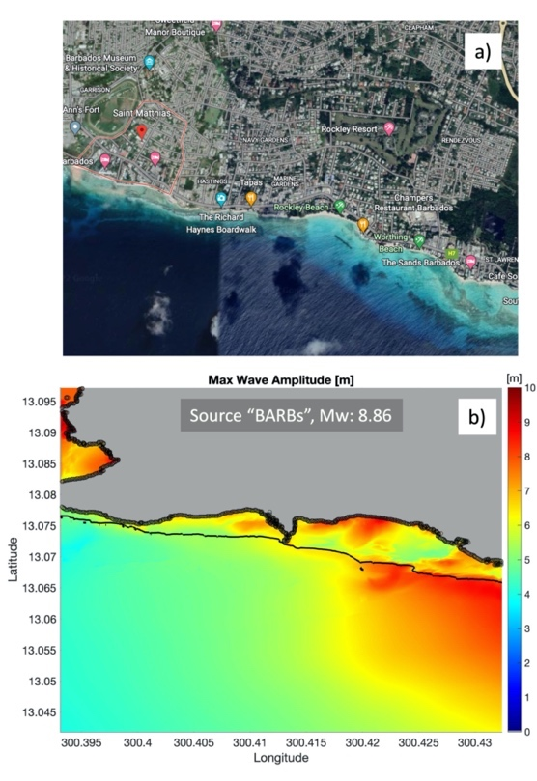
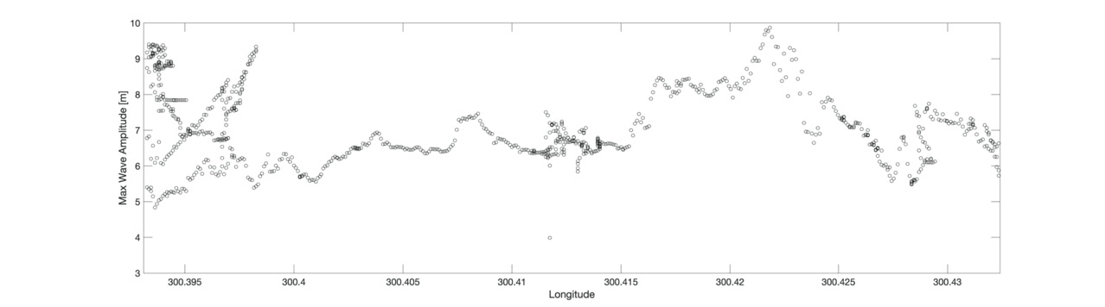
c)

Figure 16: a) Southwestern Barbados area from Saint Matthias, Bridgetown to Saint Lawrence, Oistins along the coastline (Google Earth), b) maximum wave amplitudes from the BARBs source (solid black line – initial coastline, dotted line – coastline after the tsunami maximum inundation), c) maximum wave amplitudes distribution along the coastline.

6.5. Composite Results

This project has identified eight sources with potential significant impact on Barbados, and has focused so far on the most hazardous as they provide the largest inundation. But it is possible that smaller events inundate an area that a larger source has not, either because the incident direction of wave fronts from the two sources come from different directions, or because the dynamics of the wave as it shoals causes a focusing specific to a certain source. For this reason, we create a composite maximum by taking the envelope of maximum output from each source (e.g., the maximum of the maximums) (Figure 17, a). This composite looks very much like the most hazardous source (Figure 12, a) shown in section 6.2.

Patterns for Barbados inundation are typical for those seen in most islands: low-lying beach areas experience the worst inundation especially in the areas where “island back side” waves collision happens (Figure 17). Mangroves and coral reefs tend to mitigate inundation. Cobblers Reef that consists of inner and outer parts and runs parallel to the south east coast of Barbados for approximately 15 km protects the low-lying beaches of this area (for example, Crane Beach) lowering the potential tsunami impact.

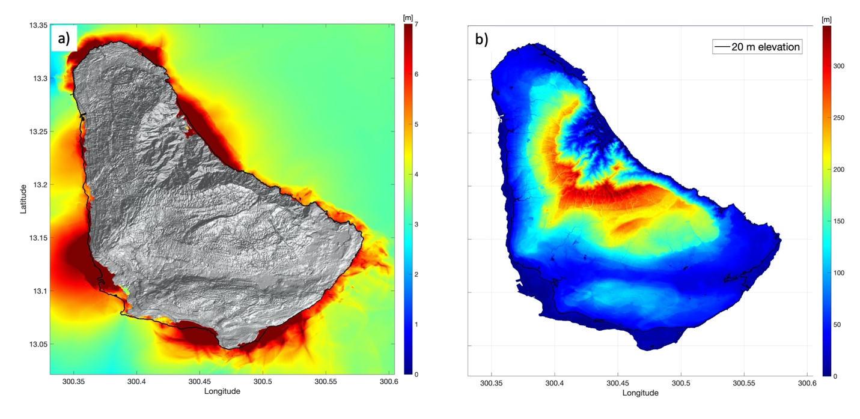
Figure 17: a) Composite maximum wave amplitude and b) Barbados topography with 20 m level elevation highlighted (black line).

7. Conclusion

The aim of this project was to do a thorough scenario-based tsunami inundation study using near-field and far-field worst-case scenarios to find the possible tsunami impact to Barbados. The results of this study show that the impact of a large, near-field tsunami from the Lesser Antilles Trench would be disastrous for Barbados in terms of lives, infrastructure, and property. Arrival times for waves from the most hazardous source range from 14 – 25 minutes, so education, planning, and preparedness are fundamentally necessary.

Barbados is situated near the location of the largest regional source of tsunamigenic earthquakes, but they are also vulnerable to far-field earthquakes. The far-field regional earthquakes will likely be smaller than the worst Lesser Antilles Subduction Zone, but the 1755 Lisbon event proves that large events from outside the Caribbean are possible. The concern is mitigated by the fact that there would be hours to evacuate coastlines if the event
originated from across the Atlantic.

Patterns for Barbados inundation are those seen in most islands: low-lying beach areas experience the worst inundation especially in the areas where “island back side” waves collision happens and also the areas where location bathymetry creates a focusing effect. The coastlines facing the near-field sources fair the significant tsunami impact. Coral reefs and mangroves tend to mitigate inundation.

This study provides a good first step toward assessing the effect of tsunamigenic earthquakes on Barbados. However, this study does not consider tsunami generating volcanic eruptions and tsunamigenic landslides that may occur due to earthquakes or volcanic activity.

While this report highlights the biggest events, the composite results were also included because it is possible that smaller events inundate an area that a larger source has not due to a particular source direction or focusing effects. This composite looks very much like the most hazardous source.

Model output products are provided (in GIS-readable ASCII format). They include the maximum wave amplitudes, the maximum flow depths as well as composite over all sources for maximum wave amplitude and flow depth.

REFERENCES

Atwater, B.F., ten Brink, U.S., Buckley, M., Halley, R.S., Jaffe, B.E., López-Venegas, A.M., Rrinhardt, E.G. Tuttle, M.P., Watt, S. Wei, Y., 2012, Geomorphic and stratigraphic evidence for an unusual tsunami or storm a few centuries ago at Anegada, British Virgin Islands, Nat. Hazards, 63, pp 51 – 84. https://doi.org/10.1007/s11069-010-9622-6

Barkan, R., ten Brink, U.S., Lin, J., 2009, Far field tsunami simulations of the 1755 Lisbon earthquake: Implications for tsunami hazard to the U.S. East Coast and the Caribbean Tsunami hazard along the U.S. Atlantic coast, Marine Geology, 264, pp. 109 – 122. https://doi.org/10.1016/j.margeo.2008.10.010

Briggs, M.J., Synolakis, C.E., Harkins, G.S., Green, D.R., 1995, Laboratory experiments of tsunami runup on a circular island, Pure and Applied Geophysics, 144 (3 – 4), pp. 569 – 593. https://doi.org/10.1007/978-3-0348-7279-9_12

GEBCO Compilation Group, 2021, GEBCO 2021 Grid. https://doi.org/10.5285/c6612cbe-50b3-0cff-e053-6c86abc09f8f

Harbitz, C.B., Glimsdal, S., Bazin, S., Zamora, N., Løvholt, F., Bungum, H., Smebye, H., Gauer, P., Kjekstad, O., 2012, Tsunami hazard in the Caribbean: Regional exposure derived from credible worst case scenarios, Continental Shelf Research, Vol. 8, pp.1 – 23. https://doi.org/10.1016/j.csr.2012.02.006

IOC-UNESCO, 2020, Experts Meeting on Sources of Tsunamis in the Lesser Antilles. Fort-de-France, Martinique (France), 18 – 20 March 2019, Paris, UNESCO, 291 p.

Kânoğlu, U., 1998, The runup of long waves around piecewise linear bathymetries, Ph.D. thesis, University of Southern California, Los Angeles, California, 292 p. https://doi.org/10.25549/usctheses-c17-385538

Lander, J.F., Whiteside, L.S., Lockridge, P.A., 2002, A brief history of tsunami in the Caribbean Sea, Science of Tsunami Hazards, Vol. 20, pp. 57 – 94.

Liu, P.L.-F., Cho, Y.S., Briggs, M.J., Kânoğlu, U., Synolakis, C.E., 1995, Runup of solitary waves on a circular island, Journal of Fluid Mechanics, 302, pp. 259 – 285. https://doi.org/10.1017/S0022112095004095

Løvholt, F., Glimsdal, S., Harbitz, C.B., Zamora, N., Nadim, F., Peduzzi, P., Dao, H.I., Smebye, H., 2011, Tsunami hazard and exposure on the global scale, Earth-Science Reviews, 0012-8252. https://doi.org/10.1016/j.earscirev.2011.10.002.

Mader, C.L., 2001, Modeling the 1755 Lisbon tsunami, Science of Tsunami Hazards, Vol. 9, pp. 93 – 98. https://doi.org/10.1016/j.quaint.2021.11.006

Molnar, P. and Sykes, L., 1969, Tectonics of the Caribbean and Middle America regions form focal mechanisms and seismicity, Geological Society of America Bulletin 80, pp. 1639 – 1684.

Moore, C., and Arcas, D., 2019, Modeling tsunami inundation for hazard assessment of the U.S. Virgin Islands, NOAA Technical Memorandum, 37 p.

NOAA National Centers for Environmental Information (NCEI), 2018, National Geophysical Data Center / World Data Service: NCEI/WDS Global Historical Tsunami Database. https://doi.org/10.7289/V5PN93H7

NTHMP, 2017, Proceedings and Results of the National Tsunami Hazard Mitigation Program 2015 Tsunami Current Modeling Workshop, February 9 – 10, 2015, Portland, Oregon: compiled by Patrick Lynett and Rick Wilson, 194 p.

Smith, W.H.F. and Sandwell, D.T., 1997, Global Seafloor Topographyfrom Satellite Altimetry and Ship Depth Sounding, Science, 277, pp. 1956 – 1962. https://doi.org/10.1126/science.277.5334.19

Synolakis, C.E., E.N. Bernard, V.V. Titov, U. Kânoğlu, F.I. González, 2008, Validation and verification of tsunami numerical models, Pure Appl. Geophys., 165 (11 – 12), pp. 2197 – 2228. https://doi.org/10.1007/s00024-004-0427-y

van Rijsingen, E., Calais, E., Jolivet, R., de Chabalier, J.-B., Robertson, R., Ryan, G., and Symithe, S., 2021, Vertical tectonic motions in the Lesser Antilles: linking short- and long-term observations, EGU General Assembly 2021, online, 19–30 Apr 2021, EGU21-934. https://doi.org/10.5194/egusphere-egu21-934, 2021.

Zahibo, N., and Pelinovsky, E., 2001, Evaluation of tsunami risk in the Lesser Antilles. Natural Hazard and Earth Sciences, Vol. 3, pp. 221 – 231. https://doi.org/10.5194/nhess-1-221-2001

Zahibo, N., and Pelinovsky, E., 2006, Tsunamis in the Lesser Antilles in Caribbean Tsunami Hazard - Proceedings of the Nsf Caribbean Tsunami Workshop, World Scientific, pp. 244 – 254. https://doi.org/10.1142/5969

